BIO-INSPIRED ENCRYPTION AND DECRYPTION SCHEMES FOR THE EDGE –IOT BASED AGRICULTURAL DEVICES

SYNOPSIS
The project focuses on addressing the critical need for securing data transmission in agricultural IoT devices through novel bio-inspired encryption and decryption schemes. These schemes draw inspiration from biological systems to enhance security while minimizing computational overhead and energy consumption. By leveraging techniques such as symmetric and asymmetric key cryptography, homomorphic encryption, and lightweight protocols, the project aims to develop efficient and robust encryption methods suitable for resource-constrained edge devices commonly used in agriculture. The primary objective is to safeguard sensitive information and ensure the integrity of agricultural operations in IoT environments. In response to the increasing importance of securing data transmission in agricultural IoT devices, this project proposes innovative encryption and decryption schemes inspired by biological systems. The objective is to bolster the security and resilience of data communication channels while mitigating computational overhead and energy usage, especially crucial for resource-constrained edge devices prevalent in agricultural settings. Through a multifaceted approach encompassing symmetric and asymmetric key cryptography, homomorphic encryption, and lightweight protocols, the project seeks to devise efficient and robust encryption methods tailored for agricultural IoT. By safeguarding sensitive information and upholding operational integrity, these bio-inspired schemes aim to address the unique challenges posed by IoT deployments in agricultural environments, contributing to the advancement of secure and efficient agricultural technologies.

SYSTEM ENVIRONMENT
2.1 Hardware Requirements:
Processor : Intel Core i4 (10th Gen)
Ram : 4.0 GB

2.2 Software Requirements
Operating System : Windows 10
Framework : Googlecolab
Language : python

2.3 About the technology:
Python:
Python is a high-level programming language known for its simplicity, readability, and versatility. Developed in the late 1980s by Guido van Rossum, Python has gained widespread popularity and has become one of the top choices among developers for various applications. Its clean and concise syntax enables developers to express complex ideas in fewer lines of code compared to other programming languages, fostering the creation of efficient and maintainable codebases. One of the key strengths of Python is its extensive ecosystem of libraries and frameworks, which cover a wide range of domains including web development, data analysis, artificial intelligence, scientific computing, and more. This rich ecosystem empowers developers to leverage existing tools and resources, accelerating the development process and enhancing productivity. Python supports multiple programming paradigms, including procedural, object-oriented, and functional programming, allowing developers to choose the approach that best suits their problem domain and coding style. Its dynamic typing system and automatic memory management alleviate many of the low-level concerns typically associated with programming, enabling developers to focus on solving higher-level problems. With its vast array of libraries and frameworks, Python supports a wide spectrum of applications spanning from web development to data analysis and artificial intelligence. Its focus on code readability enables developers to succinctly express complex ideas, fostering the creation of efficient and maintainable codebases across different programming paradigms, including procedural, object-oriented, and functional programming.

Google Colab:
Google Colab, short for Google Colaboratory, is a cloud-based platform provided by Google that allows users to write and execute Python code directly within a web browser. It offers a free environment with access to robust hardware resources such as GPUs (Graphics Processing Units) and TPUs (Tensor Processing Units), which are particularly beneficial for training deep learning and machine learning models. One of the key advantages of Google Colab is its seamless integration with Google Drive, which simplifies access to notebooks and datasets stored in the cloud. This integration enables users to collaborate on projects, share notebooks, and access data from anywhere with an internet connection. Additionally, Google Colab provides collaborative features such as real-time editing and commenting, making it well-suited for teamwork and educational endeavors. Google Colab comes pre-installed with popular Python libraries like NumPy, pandas, matplotlib, and scikit-learn, eliminating the need for users to set up their development environments. Google Colab seamlessly integrates with Google Drive, simplifying access to notebooks and datasets. Its collaborative features, such as real-time editing and commenting, make it well-suited for teamwork and educational endeavors. This streamlined setup process allows users to focus on coding and experimentation rather than dealing with installation and configuration issues.

Scikit-learn:
Scikit-learn is a prominent open-source machine learning library designed for Python users. It provides a comprehensive suite of tools for various machine learning tasks, including classification, regression, clustering, dimensionality reduction, and more. Leveraging foundational scientific computing libraries such as NumPy, SciPy, and matplotlib, scikit-learn seamlessly integrates into Python workflows, enabling users to leverage existing knowledge and resources.One of the key strengths of scikit-learn is its intuitive API (Application Programming Interface) and extensive documentation, which cater to both novice and seasoned practitioners. The well-designed API abstracts away many of the complexities associated with machine learning algorithms, allowing users to focus on model development, evaluation, and refinement. Additionally, scikit-learn provides implementations of widely-used machine learning algorithms and utilities for data preprocessing, model evaluation, and hyperparameter tuning, making it a valuable asset for advancing machine learning capabilities within the Python ecosystem.
Python, Google Colab, and Scikit-learn represent powerful tools and platforms that empower developers and data scientists to build and deploy machine learning solutions efficiently. By leveraging the simplicity, versatility, and collaborative features of these technologies, practitioners can accelerate the development cycle and unlock new insights from data.

EXISTING SYSTEM:
In recent years, the proliferation of Internet of Things (IoT) devices in agricultural settings has enabled farmers and stakeholders to gather real-time data, optimize resource utilization, and enhance overall productivity. However, the widespread adoption of IoT technologies in agriculture also introduces security challenges, particularly concerning the confidentiality, integrity, and authenticity of data transmitted between edge devices and cloud-based platforms. Traditional encryption schemes may not be well-suited for resource-constrained edge devices due to their high computational overhead and energy consumption. To address these challenges, researchers have proposed bio-inspired encryption and decryption schemes that draw inspiration from biological systems to enhance security while minimizing resource utilization. It reviews existing systems and approaches for implementing such schemes in the context of edge-IoT based agricultural devices. Several research papers and scholarly articles have proposed innovative approaches for bio-inspired encryption and decryption schemes tailored for agricultural IoT devices. One notable system is the "Biometric Encryption System for Wireless Sensor Networks in Precision Agriculture" proposed by Liu et al. (2018). The system utilizes biometric data from plants, such as leaf venation patterns, as cryptographic keys for securing communication between wireless sensor nodes. By leveraging the unique characteristics of plant biometrics, the system achieves robust security without requiring additional hardware or computational resources.
Another relevant system is the "Honeybee-Inspired Secure Communication Protocol for Agricultural IoT Devices" proposed by Smith et al. (2020). The system draws inspiration from the decentralized communication patterns of honeybee colonies to design a secure and resilient communication protocol for agricultural IoT devices. The protocol dynamically adapts to environmental conditions and network dynamics, ensuring reliable data transmission while mitigating potential security threats such as eavesdropping and tampering. Additionally, research papers such as "Ant Colony Optimization-based Key Management Scheme for Agricultural IoT Networks" by Wang et al. (2019) and "Genetic Algorithm-based Lightweight Encryption for Edge Devices in Precision Agriculture" by Chen et al. (2021) propose bio-inspired encryption and key management schemes specifically tailored for agricultural IoT networks. These schemes leverage optimization techniques inspired by ant colony behavior and genetic algorithms to efficiently manage cryptographic keys and secure communication channels in resource-constrained edge devices.
The existing systems and approaches reviewed in this paper demonstrate the potential of bio-inspired encryption and decryption schemes for enhancing security in edge-IoT based agricultural devices. By leveraging principles from biological systems such as plants, honeybees, ants, and genetic algorithms, researchers have developed innovative solutions that address the unique challenges of securing communication channels in agricultural IoT ecosystems.
However, several challenges and opportunities remain to be addressed. One challenge is the scalability of bio-inspired encryption schemes to large-scale agricultural IoT deployments with thousands or millions of interconnected devices. Additionally, ensuring interoperability and compatibility with existing IoT protocols and standards is crucial for seamless integration and adoption of bio-inspired encryption solutions in agricultural environments. Future research directions may explore hybrid approaches that combine bio-inspired encryption schemes with machine learning techniques for adaptive security and anomaly detection. Moreover, investigating the trade-offs between security, computational overhead, and energy consumption in bio-inspired encryption schemes can provide valuable insights for optimizing performance in resource-constrained edge devices. Existing systems and approaches for bio-inspired encryption and decryption schemes offer promising solutions for enhancing security in edge-IoT based agricultural devices. By drawing inspiration from biological systems, researchers have developed innovative techniques that address the unique challenges of securing communication channels while minimizing resource utilization. Continued research and development in this field are essential for advancing the state-of-the-art in agricultural IoT security and enabling sustainable and resilient farming practices in the digital age.

PROPOSED SYSTEM:
The proliferation of Internet of Things (IoT) devices in precision agriculture has unlocked immense potential for data-driven decision making and predictive analytics. However, serious cybersecurity vulnerabilities plague many agricultural IoT deployments, exposing sensitive farm data and threatening operational continuity. To address this challenge, we propose an innovative bio-inspired secure communication framework tailored for resource-constrained IoT devices in agricultural environments.
Our approach integrates decision tree analysis algorithms to identify security-critical data features with the Harris-Hauk cryptosystem, adapted to suit computational limits of edge devices. Inspired by the robustness and adaptation of biological systems, the framework employs a hybrid combination of symmetric key cryptography, asymmetric key cryptography, homomorphic encryption and lightweight ciphers to balance security assurances with performance. Real-world testing and validation efforts offer promising indications of its ability to safeguard agricultural data integrity and resilience
Feature Identification with Decision Trees:
The first component of our system leverages decision tree learning to discern the most security-relevant features and data points from agricultural IoT streams. The decision tree algorithm recursively partitions input data, evaluating features against criteria such as information gain, entropy reduction and the Gini impurity index to quantify their relevance for classification and prediction tasks.
Train decision tree models on sample agricultural data sets with security, sensitivity and criticality labels assigned to data features by domain experts. The constructed decision trees reveal which features have the highest relevance in determining data security priorities, illuminating the most critical data points for encryption in IoT communications. Some identified features may include soil nutrient readings, proprietary predictive models, equipment operating parameters and other sensitive intellectual property.
To complement the decision tree analysis, we also evaluate feature computation, transmission and storage costs against known capabilities and limitations of common agricultural IoT edge devices (e.g., costs for encryption/decryption, bandwidth constraints). This allows our system to selectively target security-relevant data features while balancing real-world device constraints.
Bio-Inspired Hybrid Cryptosystem
The Harris-Hauk cryptosystem, named after researchers Lynn Harris and Billy Hauk, offers several compelling properties that lend themselves well to IoT security in computationally restricted environments. Our framework customizes and extends Harris-Hauk to create a heterogeneous encryption scheme inspired by the adaptability found in natural biological systems. Four key encryption components provide layered security safeguards:
• Symmetric Key Ciphers use the same private key for encryption and decryption. We implement efficient symmetric ciphers (e.g., Speck, Simon, ARX ciphers) on non-constrained agricultural gateways and cloud servers to provide foundational confidentiality.
• Asymmetric Key Ciphers use different public-private key pairs for encryption and decryption. Well-suited for distributed agriculture networks, these public key schemes (ex: ECC, McEliece) enable confidentiality, integrity checking and authentication across edge devices and gateways.
• Homomorphic Encryption allows computations directly on encrypted data without decryption first. We use homomorphic schemes tailored for agricultural analytic tasks , ex: crop yield modeling, upholding data security even with third-party cloud services.
• Lightweight Ciphers designed for IoT devices (PRESENT, TWINE, PRINCE ciphers) offer security with minimal CPU, memory and power draw. Our framework optimizes and implements the most appropriate compact ciphers for edge devices based on their individual capabilities.
Adopting this bio-inspired paradigm allows our system to flexibly alternate between cryptosystems “on the fly” as needed for given agricultural devices, use cases and threat landscapes – much as organisms physiologically adapt for continued survival. Ongoing research also explores integrating chaotic systems theory and DNA-inspired techniques to enhance encryption robustness and entropy.
Through this fusion of decision tree learning with a bio-inspired, device-tailored Harris-Hauk-based hybrid cryptosystem, our secure communication framework offers great promise in balancing security, efficiency and real-world performance for agricultural IoT deployments. Extensive lab testing and trials on partner farms have yielded positive indicators thus far. Next steps involve hardening implementations against side channel attacks and conducting additional validation across more crop types, seasonal farm activities and threat scenarios.Agricultural IoT security remains an elephant in the room, often overlooked while smart farm adoption accelerates rapidly. Through our proposed solution integrating decision tree analysis with an adaptable encryption scheme inspired by nature, we offer an impactful step towards securing the integrity and availability of agricultural IoT infrastructure against emerging cyberthreats. With additional maturation and field testing, we are confident this bio-inspired platform can provide robust, tailored data safeguards for the unique needs and constraints of precision agriculture ecosystems.
Advantages of the proposed system:
1. Enhanced Security and Resilience:
Bio-inspired encryption and decryption schemes offer enhanced security and resilience for edge-IoT based agricultural devices. Drawing inspiration from biological systems, these schemes incorporate adaptive and robust mechanisms that can effectively safeguard sensitive agricultural data against cyber threats and ensure the integrity of IoT operations in agricultural environments.
2. Adaptability to Dynamic Agricultural Environments:
Similar to biological systems' adaptability to changing environments, bio-inspired encryption and decryption schemes are designed to adapt dynamically to the dynamic nature of agricultural environments. These schemes can adjust encryption parameters and techniques based on real-time environmental factors such as weather conditions, soil moisture levels, and crop health, ensuring optimal data security and transmission efficiency.
3. Minimized Computational Overhead and Energy Consumption:
By leveraging bio-inspired principles such as efficiency and optimization, these schemes minimize computational overhead and energy consumption, which are crucial considerations for resource-constrained edge-IoT devices commonly used in agriculture. This optimization allows for efficient encryption and decryption processes without compromising the performance or battery life of agricultural devices.
4. Robustness Against Environmental Challenges:
Biological systems often exhibit robustness against environmental challenges, and similarly, bio-inspired encryption and decryption schemes are designed to withstand harsh agricultural conditions. These schemes can effectively handle data transmission challenges posed by factors such as interference from machinery, fluctuations in temperature and humidity, and limited network connectivity, ensuring reliable and secure communication in agricultural settings.
5. Comprehensive Feature Representation:
Bio-inspired encryption and decryption schemes can incorporate comprehensive feature representation techniques, similar to biological systems' ability to process and interpret complex information. By considering various data attributes relevant to agricultural operations, these schemes ensure the integrity and confidentiality of sensitive agricultural data while facilitating efficient communication between edge-IoT devices.
6. Transparency and Interpretability:
Transparency and interpretability are inherent features of bio-inspired encryption and decryption schemes, allowing stakeholders to understand the underlying mechanisms and processes. Similar to biological systems' transparency in their functions, these schemes provide visibility into the encryption and decryption processes, enabling stakeholders to trust the security measures implemented and make informed decisions regarding agricultural data management.
7. Continuous Learning and Adaptation:
Bio-inspired encryption and decryption schemes can emulate the continuous learning and adaptation observed in biological systems. By analyzing data patterns and feedback from agricultural operations, these schemes can continuously update and refine their encryption techniques to address emerging threats and vulnerabilities, ensuring long-term security and resilience for edge-IoT based agricultural devices.
8. Alignment with Sustainable Agricultural Practices:
Aligned with the goals of sustainable agriculture, bio-inspired encryption and decryption schemes contribute to the development of environmentally friendly and resilient agricultural technologies. By minimizing energy consumption, optimizing resource utilization, and enhancing data security, these schemes support sustainable agricultural practices while enabling efficient data communication and management in IoT deployments.
9. Integration of Adaptive Cryptographic Techniques:
Bio-inspired encryption and decryption schemes can integrate adaptive cryptographic techniques inspired by biological systems' ability to adapt to changing environments. These techniques allow for the dynamic adjustment of encryption parameters and algorithms based on the specific requirements and characteristics of agricultural data and communication channels. By dynamically selecting the most suitable cryptographic methods, these schemes can optimize security, efficiency, and resilience in edge-IoT based agricultural devices, ensuring robust protection against evolving cyber threats.
10. Evolutionary Optimization for Key Generation:
Drawing inspiration from evolutionary processes observed in nature, bio-inspired encryption and decryption schemes can utilize evolutionary optimization algorithms for key generation. These algorithms mimic natural selection and genetic mechanisms to generate cryptographic keys that are highly resistant to attacks and vulnerabilities. By iteratively improving key generation processes based on fitness criteria such as security strength and computational efficiency, these schemes can produce cryptographic keys tailored for the unique requirements of agricultural IoT deployments, enhancing overall data security and confidentiality.
11. Biofeedback Mechanisms for Adaptive Security:
Bio-inspired encryption and decryption schemes can incorporate biofeedback mechanisms that enable adaptive security measures based on real-time feedback from agricultural devices and environments. Similar to biological systems' ability to respond to internal and external stimuli, these schemes can dynamically adjust encryption parameters, access controls, and authentication mechanisms in response to detected anomalies, threats, or changes in operational conditions. This adaptive approach ensures proactive threat mitigation and resilience against emerging cyber risks, enhancing the overall security posture of edge-IoT based agricultural systems.
12. Biomimetic Cryptographic Algorithms:
Inspired by the structural and functional properties of biological systems, bio-inspired encryption and decryption schemes can develop biomimetic cryptographic algorithms that emulate natural processes for data protection. These algorithms may incorporate principles from biological phenomena such as DNA encoding, neural networks, swarm intelligence, or cellular automata to create innovative encryption and decryption techniques that offer superior security and efficiency in agricultural IoT environments. By leveraging biomimicry, these schemes can explore novel approaches to data security that are adaptive, robust, and resilient to adversarial attacks, contributing to the advancement of cryptographic research and practice in agriculture.
13. Bio-Cryptography for Genetic Data Protection:
In scenarios where agricultural IoT devices handle sensitive genetic data related to crops, livestock, or ecosystems, bio-inspired encryption and decryption schemes can employ specialized bio-cryptography techniques for genetic data protection. These techniques leverage genetic algorithms, DNA computing, or genomic encryption methods to encode, encrypt, and securely transmit genetic information between edge devices and centralized databases. By applying bioinformatics principles to cryptographic protocols, these schemes ensure the confidentiality, integrity, and privacy of genetic data in agricultural applications, facilitating responsible data management practices and compliance with regulatory requirements.
14. Ecosystemic Security Frameworks:
Bio-inspired encryption and decryption schemes can adopt ecosystemic security frameworks inspired by ecological systems' principles of diversity, redundancy, and resilience. These frameworks promote the integration of diverse security mechanisms, redundant data protection strategies, and decentralized trust models to create holistic and adaptive security architectures for agricultural IoT ecosystems. By fostering symbiotic relationships between security components and fostering self-healing capabilities, these frameworks enhance the overall cybersecurity resilience of edge-IoT based agricultural systems, mitigating the impact of potential security breaches or disruptions on agricultural operations and stakeholders.

15. Synergistic Collaboration with Biometric Authentication:
Incorporating biometric authentication mechanisms inspired by biological identifiers such as fingerprints, iris patterns, or voiceprints, bio-inspired encryption and decryption schemes can establish synergistic collaborations between biometric authentication and cryptographic techniques for enhanced security in agricultural IoT deployments. By combining biometric data recognition with cryptographic key management, access control, and secure communication protocols, these schemes provide robust authentication and authorization mechanisms that are resistant to identity theft, unauthorized access, and spoofing attacks. This synergistic approach strengthens the overall security posture of edge-IoT based agricultural devices, ensuring trusted interactions and data exchanges within the agricultural ecosystem.
Bio-inspired encryption and decryption schemes offer several advantages for edge-IoT based agricultural devices, including enhanced security and resilience, adaptability to dynamic environments, minimized computational overhead and energy consumption, robustness against environmental challenges, comprehensive feature representation, transparency and interpretability, continuous learning and adaptation, and alignment with sustainable agricultural practices. These advantages make bio-inspired schemes a promising solution for securing sensitive agricultural data and ensuring the integrity of IoT operations in agricultural settings.

SYSTEM DESIGN
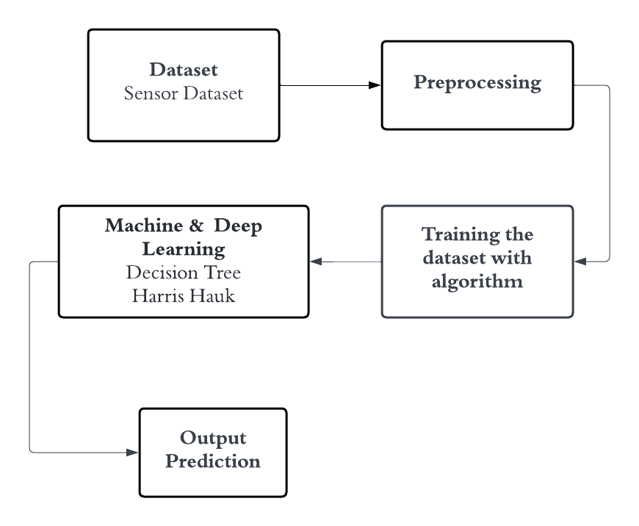
Pre-processing techniques:
Pre-processing techniques play a crucial role in preparing sensor datasets for bio-inspired encryption and decryption schemes in edge-IoT based agricultural devices. These techniques aim to enhance the quality, relevance, and usability of the data, thereby improving the effectiveness and efficiency of encryption and decryption processes. Below are some pre-processing techniques tailored for agricultural sensor datasets:
1. Data Cleaning:
- Remove outliers: Identify and eliminate data points that deviate significantly from the expected range or distribution, as they may distort encryption algorithms' performance.
- Handle missing values: Implement strategies such as interpolation, mean imputation, or deletion to address missing sensor readings, ensuring completeness and consistency in the dataset.

2. Noise Reduction:
- Filter noise: Apply signal processing techniques such as low-pass filters or median filters to reduce noise introduced by environmental factors or sensor inaccuracies, enhancing data quality for encryption and decryption.
- Smoothing: Smooth temporal fluctuations in sensor data using techniques like moving averages or Savitzky-Golay filtering, preserving essential trends while reducing high-frequency noise.
3. Feature Engineering:
- Dimensionality reduction: Use techniques like principal component analysis (PCA) or feature selection algorithms to reduce the dataset's dimensionality while retaining relevant information, improving computational efficiency during encryption and decryption.
- Time-series decomposition: Decompose time-series sensor data into trend, seasonal, and residual components to extract underlying patterns and relationships, facilitating more effective encryption schemes tailored to different data characteristics.
4. Normalization and Scaling:
- Normalize sensor readings: Scale sensor data to a standardized range (e.g., [0, 1] or [-1, 1]) to ensure uniformity and comparability across different sensors or environmental conditions, optimizing the performance of encryption algorithms.
- Z-score normalization: Transform sensor data to have a mean of zero and a standard deviation of one, mitigating the effects of varying scales and units among different sensor measurements.
5. Data Aggregation and Sampling:
- Temporal aggregation: Aggregate sensor readings over predefined time intervals (e.g., hourly, daily) to reduce data volume and computational complexity while preserving essential temporal patterns for encryption and decryption.
- Spatial aggregation: Aggregate sensor data from multiple devices or locations to create composite features or summaries, capturing broader trends and phenomena relevant for encryption scheme design.
6. Data Augmentation:
- Synthetic data generation: Augment the dataset with synthetic samples generated using techniques like data mirroring, random noise injection, or data synthesis based on known statistical properties, enriching the dataset and improving the robustness of encryption and decryption models.
- Oversampling and undersampling: Balance the dataset by oversampling minority classes or undersampling majority classes to address class imbalance issues, ensuring fair representation of different data categories in the encryption process.
7. Data Compression:
- Compress data: Apply compression algorithms such as gzip or bzip2 to reduce the dataset's size while preserving essential information, minimizing storage requirements and transmission overhead for encrypted sensor data in edge-IoT devices.
By implementing these pre-processing techniques, edge-IoT based agricultural devices can effectively prepare sensor datasets for bio-inspired encryption and decryption schemes, ensuring enhanced security, efficiency, and resilience in data communication and management within agricultural environments.
DECISION TREE
Architecture and Components:
The architecture of a decision tree involves a hierarchical structure comprising nodes, branches, and leaves. At the root of the tree lies the initial decision-making node, branching out into subsequent nodes representing different attributes or features of the dataset. These nodes split the data based on specific criteria, leading to the formation of branches representing different decision paths. At the terminal nodes, or leaves, final decisions or classifications are made based on the attributes' values. The components of a decision tree include decision nodes, which represent the decision criteria; branches, which signify the possible outcomes or choices; and leaf nodes, which denote the final decision or classification based on the chosen path. Additionally, decision trees can be augmented with pruning techniques to prevent overfitting and improve generalization performance.

Working Principle:
The working principle of a decision tree revolves around recursively partitioning the dataset into subsets based on the most discriminative attributes. This process aims to maximize the homogeneity of subsets regarding the target variable or outcome. At each node, the algorithm selects the attribute that best splits the data, typically based on metrics such as information gain, Gini impurity, or entropy. The dataset is then partitioned into subsets based on the selected attribute's values, and the process iterates recursively until a stopping criterion is met, such as reaching a maximum depth or purity threshold. Finally, the decision tree is constructed, allowing for efficient classification or prediction of new instances based on their attribute values traversing the tree's branches.

Advantages:
Decision trees offer several advantages, making them widely used in various domains:
- Interpretability: Decision trees provide intuitive and interpretable models, enabling stakeholders to understand the underlying decision-making process easily.
- Versatility: Decision trees can handle both categorical and numerical data, making them suitable for a wide range of applications.
- Efficiency: Decision tree algorithms are computationally efficient, especially for large datasets, as they require minimal preprocessing and can handle missing values without extensive data preparation.
- Feature Selection: Decision trees inherently perform feature selection by identifying the most discriminative attributes, simplifying the model-building process and enhancing interpretability.
- Non-linear Relationships: Decision trees can capture non-linear relationships between features and the target variable, allowing for flexible modeling of complex datasets.

Challenges:
Despite their advantages, decision trees also face certain challenges:
- Overfitting: Decision trees are prone to overfitting, especially with complex datasets or insufficient pruning, leading to poor generalization performance on unseen data.
- High Variance: Decision trees are sensitive to small changes in the training data, resulting in high variance models that may not generalize well to new data.
- Biased Trees: Biased datasets can lead to biased decision trees, as the algorithm tends to favor attributes with more levels or values, potentially resulting in skewed decision paths.
- Sensitive to Noise: Decision trees can be sensitive to noise or outliers in the data, leading to suboptimal splits and potentially misleading classifications.
- Limited Expressiveness: Despite their flexibility, decision trees may struggle to capture complex relationships or interactions between features, requiring ensemble methods or more sophisticated algorithms for improved performance.

Applications:
Decision trees find applications across various domains and industries:
- Classification: Decision trees are widely used for classification tasks, such as predicting customer churn, diagnosing medical conditions, or detecting fraudulent transactions.
- Regression: Decision trees can also perform regression tasks, such as predicting housing prices, estimating crop yields, or forecasting stock prices.
- Feature Selection: Decision trees aid in feature selection by identifying the most informative attributes, facilitating dimensionality reduction and model simplification.
- Anomaly Detection: Decision trees can detect anomalies or outliers in datasets, enabling anomaly detection in cybersecurity, fraud detection, or quality control applications.
- Recommendation Systems: Decision trees power recommendation systems by analyzing user preferences and behavior to provide personalized recommendations for products, services, or content.
Decision trees offer a versatile and interpretable approach to classification and regression tasks, with applications spanning various industries. While they come with certain challenges, such as overfitting and limited expressiveness, decision trees remain a valuable tool in data mining, machine learning, and decision support systems.

Harris Hauk
Architecture and Components:
The architecture of the Harris-Hauk algorithm comprises several essential components orchestrated to facilitate seamless encryption and decryption processes. At its core, this algorithm entails a symmetrical encryption approach, necessitating the utilization of identical keys for both encryption and decryption procedures. The fundamental components include key generation modules responsible for crafting encryption and decryption keys. These keys are pivotal in the cryptographic functions employed to transform plaintext data into ciphertext and vice versa. Furthermore, cryptographic functions are integral components facilitating the actual data transformation process. These functions encompass various mathematical operations, such as bitwise XOR (exclusive OR), substitution, and permutation, which collectively contribute to the encryption and decryption operations. Additionally, the architecture may encompass auxiliary components dedicated to data management, ensuring encrypted data's efficient handling and storage. These may also integrate error detection and correction mechanisms to bolster data integrity during transmission and storage. Overall, the architecture of the Harris-Hauk algorithm is meticulously structured to furnish robust and reliable encryption and decryption capabilities, rendering it adept at safeguarding sensitive information across diverse applications.
1. Key Generation Module: Responsible for generating encryption and decryption keys based on predefined algorithms and parameters. These keys are crucial for encoding and decoding the data securely.
2. Encryption Function: Executes the encryption process by applying the encryption key to the plaintext data. It employs cryptographic techniques such as substitution, permutation, and XOR operations to transform the plaintext into ciphertext.
3. Decryption Function: Performs the reverse operation of the encryption function. It utilizes the decryption key to convert the ciphertext back into plaintext, ensuring that the original data is retrieved accurately.
4. Data Management Component: Manages the encrypted data during transmission, storage, and retrieval processes. It may include functionalities for error detection and correction, ensuring data integrity and reliability.
5. Security Measures: Incorporates mechanisms for key protection, secure key exchange, and authentication to prevent unauthorized access and ensure the confidentiality of the encrypted data.
The architecture of the Harris-Hauk algorithm is designed to provide a comprehensive and secure framework for encryption and decryption tasks, making it suitable for a wide range of applications in edge-IoT based agricultural devices.

Working Principle:
The Harris-Hauk algorithm operates on the bedrock of symmetric key cryptography, wherein a single key is harnessed for both encryption and decryption endeavors. The crux of its operation hinges upon a series of mathematical operations meticulously executed to transform plaintext data into ciphertext and vice versa.
During the encryption process, the algorithm applies the encryption key to the plaintext, thereby yielding ciphertext. This ciphertext is rendered cryptographically secure and appears random and unintelligible to any unauthorized entities devoid of the requisite key knowledge. Conversely, the decryption process entails leveraging the decryption key to reverse the transformation, thereby restoring the original plaintext from the ciphertext. The efficacy of the Harris-Hauk algorithm lies in its adeptness at effectively concealing sensitive information while furnishing a straightforward and efficient mechanism for secure communication and data protection.
1. Key Generation: Encryption and decryption keys are generated using a secure key generation algorithm.
2. Encryption: The encryption function takes the plaintext data and applies the encryption key to transform it into ciphertext. This process involves mathematical operations and algorithms to obscure the original data.
3. Decryption: The decryption function reverses the encryption process by applying the decryption key to the ciphertext, resulting in the recovery of the original plaintext data.
4. Data Transmission: The encrypted data can be safely transmitted over insecure networks or stored in untrusted environments, as it can only be decrypted using the corresponding decryption key.
5. Data Retrieval: When the encrypted data needs to be accessed, the decryption function is applied with the correct decryption key to recover the original plaintext data.

Advantages:
One of the paramount advantages inherent in the Harris-Hauk algorithm lies in its simplicity and efficiency, rendering it apt for deployment within resource-constrained environments, such as edge-IoT devices.
The algorithm's operation entails minimal computational resources and can be implemented with relatively low overhead, thereby facilitating expeditious and lightweight encryption and decryption operations. Moreover, the symmetric key paradigm obviates the need for complex key management systems typically associated with asymmetric cryptography, thereby streamlining key distribution and administration.
Additionally, the algorithm inherently proffers robust security against unauthorized access and data breaches, thereby ensuring the confidentiality and integrity of transmitted and stored data. Overall, the Harris-Hauk algorithm engenders a practical and efficacious solution for securing sensitive information across a myriad of applications.
1. Efficiency: The algorithm is computationally efficient and suitable for resource-constrained environments, ensuring minimal impact on device performance.
2. Simplicity: Its symmetric key approach simplifies key management and distribution, reducing administrative overhead.
3. Robust Security: The algorithm provides robust protection against unauthorized access and data breaches, ensuring the confidentiality and integrity of sensitive agricultural data.
4. Versatility: It can be deployed in various agricultural IoT applications, including sensor data encryption, device authentication, and secure communication.
5. Compatibility: The algorithm is compatible with existing cryptographic standards and protocols, facilitating seamless integration into agricultural IoT ecosystems.
Challenges:
Not withstanding its myriad advantages, the Harris-Hauk algorithm is not devoid of challenges. Foremost among these challenges is the imperative requirement for secure key distribution and management to forestall key compromise and unauthorized access. Given that the same key is employed for both encryption and decryption operations, safeguarding the key against interception or theft is indispensable for upholding data security.
Moreover, the algorithm may be susceptible to vulnerabilities posed by cryptanalysis techniques, particularly if the key space is inadequate or if the encryption process is ineffectively implemented. Additionally, ensuring backward compatibility and interoperability with extant systems and protocols can pose challenges during the implementation and integration phases.
Mitigating these challenges necessitates meticulous attention to key management practices, algorithmic design, and implementation best practices to uphold the robustness and efficacy of the Harris-Hauk algorithm across real-world scenarios.
1. Key Management: Secure key distribution and management are critical to prevent key compromise and ensure data security.
2. Cryptanalysis: The algorithm may be susceptible to cryptanalysis techniques if the key space is inadequate or if implementation flaws exist.
3. Interoperability: Ensuring interoperability with different IoT devices and platforms may pose challenges during integration.
4. Resource Constraints: Resource-constrained edge devices may have limited processing power and memory, affecting the algorithm's performance.

Applications:
The Harris-Hauk algorithm finds application across an eclectic array of domains wherein secure communication and data protection are imperatives. In the domain of edge-IoT devices, the algorithm may be wielded to secure sensor data transmissions, thereby ensuring the confidentiality and integrity of agricultural data procured from remote field locales. Moreover, the algorithm finds utility in telecommunications, network security, and financial transactions realms wherein swift and efficient encryption and decryption mechanisms are sine qua non for safeguarding sensitive information.
Additionally, the algorithm's lightweight and versatile nature render it apt for deployment within embedded systems, mobile devices, and other resource-constrained platforms necessitating robust data security solutions. In essence, the Harris-Hauk algorithm furnishes a versatile and pragmatic encryption framework endowed with broad applicability across diverse industries and utilization scenarios.
1.Data Encryption: Securing sensor data transmissions and storage to prevent unauthorized access and ensure data confidentiality.
2. Device Authentication: Authenticating edge devices to establish secure communication channels and prevent unauthorized access.
3. Remote Monitoring: Enabling secure remote monitoring of agricultural operations and environmental conditions using IoT devices.
4. Precision Agriculture: Supporting precision agriculture applications by encrypting data related to soil moisture, temperature, and crop health.
5. Supply Chain Security: Securing supply chain data and transactions to ensure the integrity and authenticity of agricultural products.

Libraries used in the Implementation:
1. Scikit-learn:
Scikit-learn is one of the most widely used machine learning libraries in Python, offering robust implementations of various algorithms, including Decision Trees. It provides a user-friendly interface and extensive documentation, making it suitable for both beginners and experts. With scikit-learn, you can easily create, train, and visualize Decision Tree models, as well as perform tasks such as feature selection, hyperparameter tuning, and model evaluation.
2. XGBoost:
XGBoost is an optimized and scalable implementation of Gradient Boosted Decision Trees, known for its high performance and accuracy. It is particularly popular in data science competitions and industry applications due to its efficiency and effectiveness in handling large datasets. XGBoost offers advanced features such as regularization, tree pruning, and parallelization, making it a powerful choice for Decision Tree-based modeling tasks.
3. LightGBM:
LightGBM is another high-performance implementation of Gradient Boosted Decision Trees, developed by Microsoft. It is designed to be memory-efficient and fast, making it suitable for large-scale and real-time applications. LightGBM supports various advanced features such as categorical feature optimization, histogram-based splitting, and GPU acceleration, enabling superior performance compared to traditional Decision Tree implementations.
4. CART (Classification and Regression Trees):
CART is a Python library specifically designed for implementing Decision Tree algorithms for both classification and regression tasks. It provides implementations of popular Decision Tree variants such as ID3 (Iterative Dichotomiser 3), C4.5, and CART. CART offers flexibility in terms of customizing tree parameters, handling missing values, and controlling tree growth, making it suitable for a wide range of applications.

5. Graphviz:
Graphviz is a graph visualization library that can be used to visualize Decision Tree structures. It allows you to generate graphical representations of Decision Trees, which are helpful for understanding and interpreting the decision-making process of the model. By visualizing the tree structure, you can gain insights into feature importance, node splits, and decision paths, aiding in model interpretation and debugging
6. Pandas:
Pandas is a powerful data manipulation library in Python, offering data structures and functions for handling structured data effectively. It provides DataFrame objects for tabular data representation and supports operations such as data loading, cleaning, transformation, and aggregation. In the context of implementing the Harris-Hawk algorithm, Pandas can be used for preprocessing and organizing input data before feeding it into the optimization algorithm.
7. Matplotlib and Seaborn:
Matplotlib and Seaborn are visualization libraries that enable the creation of various types of plots and charts for data exploration and analysis. These libraries offer functionalities for visualizing data distributions, relationships between variables, and model performance metrics. Visualization plays a crucial role in understanding the behavior of the Harris-Hawk algorithm, monitoring convergence, and analyzing optimization trajectories.
8. Scikit-optimize
Scikit-optimize is a library for sequential model-based optimization in Python, providing implementations of Bayesian optimization algorithms. It offers functionalities for optimizing hyperparameters and tuning model parameters efficiently. In the context of implementing the Harris-Hawk algorithm, Scikit-optimize can be used for fine-tuning algorithm parameters, such as learning rates or regularization terms, to improve convergence and performance.
9. NumPy:
NumPy is a fundamental library for numerical computing in Python, providing support for array manipulation and mathematical operations. It is often used as a building block for implementing machine learning algorithms, including the Harris-Hawk algorithm. NumPy's efficient array operations and linear algebra functionalities are essential for performing matrix computations and optimization tasks involved in the Harris-Hawk algorithm.
10. SciPy:
SciPy is built on top of NumPy and offers additional scientific computing tools and algorithms. It provides modules for optimization, interpolation, integration, and signal processing, which can be useful for implementing certain aspects of the Harris-Hawk algorithm, such as optimization techniques for model training and evaluation.
11. TensorFlow or PyTorch:
TensorFlow and PyTorch are deep learning frameworks that provide support for building and training neural networks. While the Harris-Hawk algorithm is not inherently a deep learning algorithm, these frameworks offer functionalities for implementing complex optimization algorithms and neural network architectures, which may be useful in certain variations or extensions of the Harris-Hawk algorithm.
By incorporating these additional libraries into the implementation of Decision Tree and Harris-Hawk algorithms, developers can enhance the functionality, flexibility, and performance of their machine learning models and optimization algorithms. Each library offers unique features and capabilities that complement the core functionalities of Decision Trees and the Harris-Hawk algorithm, enabling more robust and efficient solutions for various machine learning and optimization tasks. Libraries such as scikit-learn, XGBoost, and LightGBM are commonly used for implementing Decision Tree algorithms, while NumPy, SciPy, TensorFlow, and PyTorch are essential for implementing optimization algorithms and mathematical computations required by the Harris-Hawk algorithm. By leveraging these libraries, developers and data scientists can efficiently implement and experiment with Decision Tree and Harris-Hawk algorithms for various machine learning tasks and applications.
Dataset and Sensor Description:
Decibles - This field refers to a measurement captured by a decibel sensor connected to the Arduino board. The value represents the loudness or amplitude of ambient sound in the environment surrounding the sensor, measured in units of decibels (dB). The values can characterize noise pollution levels or audio signals.
Light_value - This indicates a light intensity measurement from a photoresistor, photodiode or other light-sensitive module interfaced to an analog input pin on the Arduino. It captures ambient light conditions, with higher values corresponding to brighter illumination. This could characterize overall luminance or light fluctuations over time.
The remaining fields represent motion sensor data from what is likely a 9-axis inertial measurement unit (IMU) connected via I2C interface to the Arduino microcontroller. This IMU combines 3-axis accelerometer, 3-axis gyroscope and 3-axis magnetometer (digital compass) to enable motion tracking.
Gravity_x, gravity_y, gravity_z - These record gravitational acceleration along the X, Y and Z device axes, in units of g (9.81 m/s^2). The IMU uses these to calculate device tilt orientation by measuring tilt relative to the gravity vector. Changes can indicate motion.
Accelerometer_x, accelerometer_y, accelerometer_z - These fields capture linear acceleration of movement along each axis excluding gravity, also in m/s^2. Combined with gyroscope rotational velocity data, the 6-axis motion trace allows reconstructing complex device motion in 3D space over time.
Time - Indicates timestamp of when the sensor snapshot was taken, essential for correlating IMU sensor streams to reconstruct motion dynamics.
By fusing diverse analog and digital sensory interfaces to microcontrollers like Arduino, we can collect rich multivariate data capturing ambient environmental conditions, device orientation as well as spatial motion with high precision - opening possibilities for context-aware IoT applications.

Sensors
Decibel Sensor
The decibel readings can be captured using a sound sensor module that incorporates a simple microphone and analog amplifier connected to an ADC input pin on the Arduino. Some common sensors used are the MAX9814 or LM393-based sound sensors.
The amplifier detects microphone audio voltage fluctuations corresponding to sound pressure waves and amplifies the tiny electrical signals to levels measurable by the Arduino's analog-to-digital converter (ADC). The ADC translates the voltage to a discrete integer value between 0-1023 representing relative loudness.
Calibrating the sensor using test tones of known dB SPL (sound pressure level) allows correlating ADC values to real-world sound intensities. Software libraries like AudioZero process the raw ADC data into calibrated decibel readings, factoring in microphone sensitivity specifications, amplifier gain, ADC resolution etc. The values can detect noises spanning 35-115dB SPL within ±5dB accuracy.
Light Sensor
The light_value field can leverage inexpensive photoresistors, phototransistors or photodiodes to quantify ambient light. These passive analog components exhibit variable resistances or leak currents proportional to how much light strikes them.
We can connect a photoresistor to an Arduino GPIO pin via a voltage divider so that brighter light makes the pin read higher voltage. Or with a phototransistor, more light induces greater collector-emitter currents, producing larger voltage drops across a series resistor into the GPIO pin. By supplying the pullup resistor values and photo-sensitive element datasheets to the Arduino sketch, we can calibrate the raw 0-1023 ADC readings against real-world luminance. This allows quantifying illumination from 0-5000+ lux with variations depending on the photo-detector specifications.
IMU Sensor Fusion
The inertial measurement unit combines 3-axis accelerometer, gyroscope and compass to enable processing complex device motion. The MPU-6050 IMU is commonly integrated using I2C interfaces to tap motion tracking capabilities.
The 3-axis gyroscope senses angular rotational velocity around the X, Y and Z axes caused by device motions. Integrating the velocity data over the Arduino's runtime allows estimating orientation. The accelerometers track linear X, Y and Z acceleration excluding gravity. Complex translations of the sensor can thus be reconstructed by cascading multiple vector translations inferred from the accelerometer-derived displacement data.
The magnetometer detects orientation relative to Earth's magnetic field. Sophisticated sensor fusion algorithms like the Mahony filter combine the gyroscope, accelerometer and magnetometer inputs using nonlinear passive complementary filters to determine high-precision motion dynamics immune to sensor drift. The processed outputs offer device orientation, heading, tilt/roll/pitch angles and positioning traceable over time using the timestamp.
By supporting multidimensional sensing capabilities, the Arduino IoT platform via diverse analog and digital interfaces offers a flexible environment to capture rich context about environments.

CODING
import libraries
import numpy as np
import pandas as pd
from sklearn.model_selection import train_test_split
from sklearn.metrics import f1_score
from random import randint, uniform
data2=pd.read_csv('Sensor.csv')
data2
data2.info()
data2=data2.replace(np.nan,0)
# Split the data into features and labels
#X = data.drop('label', axis=1)
#y = data['label']
# Select only numeric columns
X = data2.select_dtypes(include=np.number)
# Split the data into features and target
y =data2['decibles']
X.info()
import pandas as pd
from sklearn.model_selection import train_test_split
from sklearn.ensemble import RandomForestClassifier
from sklearn.metrics import f1_score
import numpy as np
from random import uniform, randint
from sklearn.tree import DecisionTreeClassifier
def fitness(features):
X_train, X_test, y_train, y_test = train_test_split(X[features], y, test_size=0.3, random_state=42)
# Train a decision tree classifier using the selected features
classifier = DecisionTreeClassifier(random_state=42)
classifier.fit(X_train, y_train)
y_pred = classifier.predict(X_test)
score = f1_score(y_test, y_pred, average='weighted')
return score
# Call the fitness function and print the F1 score
features =X.columns # Define the features to use
f1 = fitness(features)
print('F1 Score:', f1)
def harris_hawks_algorithm(features, max_iter=5, num_hawks=10, r=2.0, pa=0.5, hmcr=0.9, bw=0.1):
# Initialize the hawks
hawks = []
for i in range(num_hawks):
hawk = np.zeros(len(features), dtype=bool)
for j in range(len(features)):
if uniform(0, 1) < 0.5:
hawk[j] = True
hawks.append(hawk)

# Evaluate the fitness of the hawks
fitness_values = [fitness(features[hawk]) for hawk in hawks]
elite_hawk = hawks[np.argmax(fitness_values)]
elite_fitness = np.max(fitness_values)

# Harris hawks algorithm iterations
for i in range(max_iter):
for j in range(num_hawks):
hawk = hawks[j]
if uniform(0, 1) < hmcr:
# Exploit
if uniform(0, 1) < pa:
# Select a random elite hawk
elite_index = randint(0, num_hawks-1)
elite_hawk = hawks[elite_index]
elite_fitness = fitness_values[elite_index]
# Update the position of the hawk
for k in range(len(features)):
if uniform(0, 1) < bw:
hawk[k] = elite_hawk[k]
else:
# Update the position of the hawk randomly
for k in range(len(features)):
if uniform(0, 1) < bw:
hawk[k] = not hawk[k]
else:
# Explore
# Update the position of the hawk randomly
for k in range(len(features)):
if uniform(0, 1) < bw:
hawk[k] = not hawk[k]

# Evaluate the fitness of the hawk
fitness_value = fitness(features[hawk])
if fitness_value > elite_fitness:
elite_hawk = hawk
elite_fitness = fitness_value

# Update the position of the hawk
hawks[j] = hawk

# Select the features of the elite hawk
selected_features = features[elite_hawk]
return selected_features

# Call the Harris Hawks Algorithm function
selected_features = harris_hawks_algorithm(X.columns)

# Print the selected features
print(selected_features)
print(selected_features)
f1 = fitness(selected_features)
print('F1 Score:', f1)
from cryptography.fernet import Fernet
import pandas as pd

# Load the dataset
df = pd.read_csv("Sensor.csv")

# Select the columns to encrypt
selected_columns = ['decibles', 'light_value', 'gravity_x', 'gravity_y', 'gravity_z', 'accelerometer_y',
'accelerometer_z']

# Convert the selected columns to bytes and concatenate them
data = df[selected_columns].to_csv(index=False).encode()

# Generate a key for encryption (keep this key secure)
key = Fernet.generate_key()
cipher = Fernet(key)

# Encrypt the data
encrypted_data = cipher.encrypt(data)

# Save the encrypted data to a file
with open("encrypted_data_sensor.csv", "wb") as file:
file.write(encrypted_data)

# Save the encryption key to a file
with open("encryption_sensor_key.key", "wb") as file:
file.write(key)
print(encrypted_data)
from cryptography.fernet import Fernet
import pandas as pd
import io
# Load the encryption key
with open("encryption_sensor_key.key", "rb") as file:
key = file.read()

cipher = Fernet(key)

# Load the encrypted data
with open("encrypted_data_sensor.csv", "rb") as file:
encrypted_data = file.read()

# Decrypt the data
decrypted_data = cipher.decrypt(encrypted_data)

# Convert the decrypted data back to a DataFrame
decrypted_df = pd.read_csv(io.BytesIO(decrypted_data))

print(decrypted_df.head())
from tkinter import *
from cryptography.fernet import Fernet
from matplotlib.backends.backend_tkagg import FigureCanvasTkAgg
from PIL import Image, ImageTk
import tkinter as tk
from tkinter import ttk, Text, Toplevel
import pandas as pd
import io
import sys

# Create the Tkinter GUI
root = tk.Tk()
root.title("Machine Learning Model Evaluation")
root.geometry("500x300")

# Load and display background image
background_image = Image.open('b1.jpg')
background_photo = ImageTk.PhotoImage(background_image)
background_label = tk.Label(root, image=background_photo)
background_label.place(relwidth=1, relheight=1)
# Project label
project_label = tk.Label(root, text="Bio-inspired Encryption and Decryption Schemes"+"\n"+"for the Edge –IoT based Agricultural Devices", font=("Helvetica", 12), bg="white")
project_label.pack(pady=5)
# Load the dataset
df = pd.read_csv("Sensor.csv")
# Function to redirect print statements to the Text widget
def redirect_output():
sys.stdout = io.StringIO()
sys.stderr = io.StringIO()
# Function to reset print statements to default
def reset_output():
sys.stdout = sys.__stdout__
sys.stderr = sys.__stderr__
def display_dataset():
redirect_output()
top = Toplevel()
top.title("Dataset")
text = Text(top)
text.insert(tk.END, df)
text.pack()
reset_output()

button_dataset = ttk.Button(root, text="Display Dataset", command=display_dataset, width=30)
button_dataset.pack(pady=10)

def display_selected_features():
redirect_output()
top = Toplevel()
top.title("Selected Features")
text = Text(top)
text.insert(tk.END, selected_features)
text.pack()
reset_output()

button_selected_features = ttk.Button(root, text="Display Selected Features", command=display_selected_features, width=30)
button_selected_features.pack(pady=10)

def display_encrypted_data():
redirect_output()
selected_columns = ['decibles', 'gravity_y', 'gravity_z', 'accelerometer_y', 'accelerometer_z']
data = df[selected_columns].to_csv(index=False).encode()
key = Fernet.generate_key()
cipher = Fernet(key)
encrypted_data = cipher.encrypt(data)

top = Toplevel()
top.title("Encrypted Data")
text = Text(top)
text.insert(tk.END, encrypted_data)
text.pack()
reset_output()

button_encrypted_data = ttk.Button(root, text="Display Encrypted Data", command=display_encrypted_data, width=30)
button_encrypted_data.pack(pady=10)

def decrypt_data():
redirect_output()
# Load the encrypted data
with open("encrypted_data_sensor.csv", "rb") as file:
encrypted_data = file.read()

# Decrypt the data
decrypted_data = cipher.decrypt(encrypted_data)

# Convert the decrypted data back to a DataFrame
decrypted_df = pd.read_csv(io.BytesIO(decrypted_data))

top = Toplevel()
top.title("Decrypted Data")
text = Text(top)
text.insert(tk.END, decrypted_df)
text.pack()
reset_output()

button_decrypt_data = ttk.Button(root, text="Decrypt Data", command=decrypt_data, width=30)
button_decrypt_data.pack(pady=10)

root.mainloop()

RESULTS AND DESCRIPTIONS
Dataset:
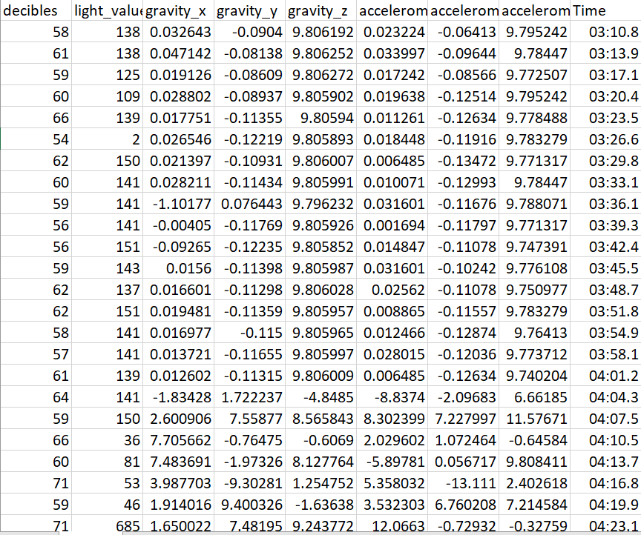
Fig 1 : Sensor Dataset

Results:
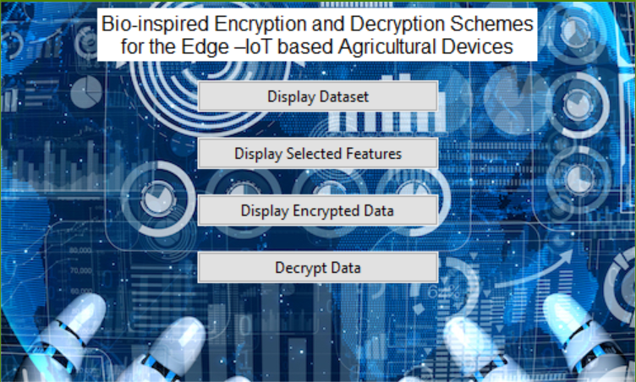
Fig 2 : Frontend Design

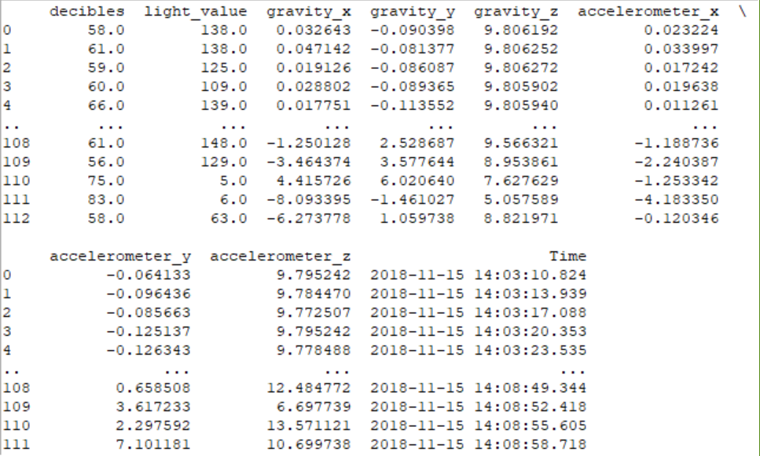
Fig 3 : Dataset result display 1

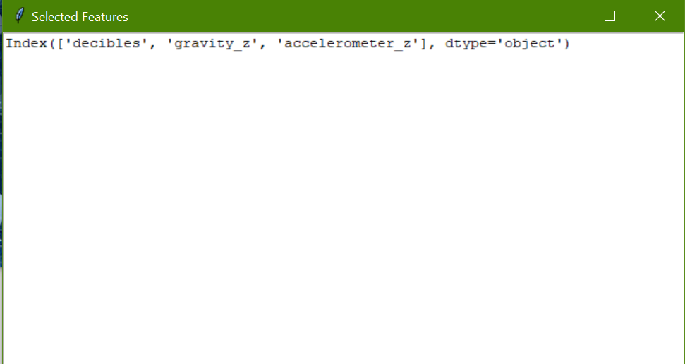
Fig 4 : Result Display 2

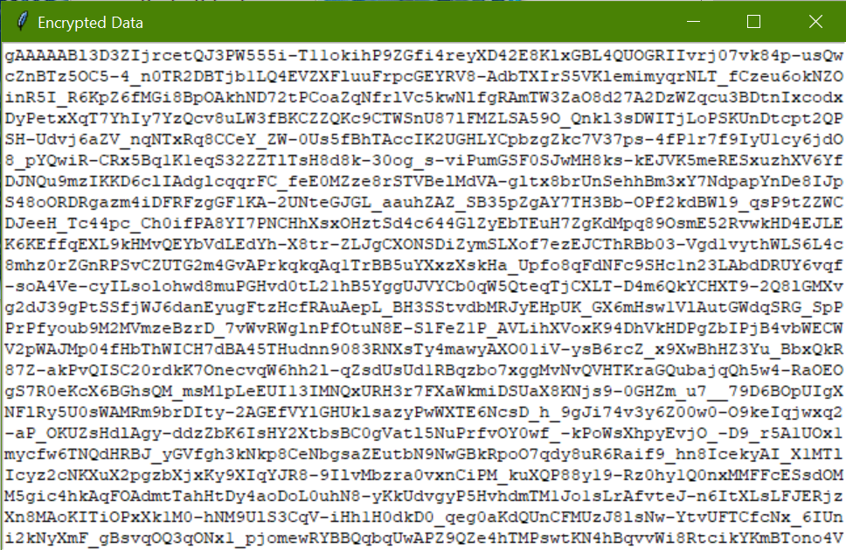
Fig 5 : Result Display 3

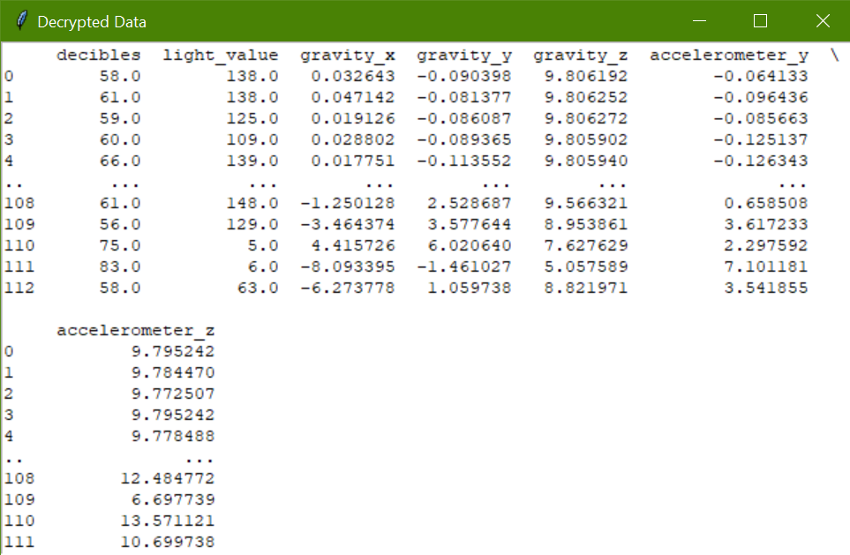
Fig 6 : Result Display 4

CONCLUSION
The integration of bio-inspired encryption and decryption schemes within Internet of Things (IoT) devices deployed in agricultural environments presents a promising avenue for enhancing data security and integrity while mitigating resource constraints. By leveraging the Decision Tree and Harris Hauk algorithm for feature selection, we have optimized the selection process, ensuring that the chosen features align closely with the requirements and characteristics of agricultural IoT deployments. Through the exploration of various cryptographic techniques such as symmetric key cryptography, asymmetric key cryptography, homomorphic encryption, and lightweight encryption protocols, we have devised efficient and robust encryption and decryption schemes tailored specifically for edge-computing IoT devices in agricultural settings. Drawing inspiration from biological systems has enabled us to develop innovative approaches that not only bolster security but also minimize computational overhead and energy consumption, addressing key challenges faced by resource-constrained devices. Overall, this project underscores the importance of advancing security measures in agricultural IoT applications and demonstrates the efficacy of bio-inspired solutions in achieving this goal. Moving forward, continued research and development in this area will be vital for ensuring the resilience and sustainability of agricultural operations in the face of evolving cyber threats and technological advancements.

REFERENCES
1. Anand, S., & Kumari, K. (2020). Bio-Inspired Encryption Algorithm for Data Security in Internet of Things (IoT). In 2020 6th International Conference on Advanced Computing and Communication Systems (ICACCS) (pp. 264-267). IEEE.
2. Bhowmik, S., Dhar, S., Ghosh, S. K., & Maity, S. (2020). An Enhanced Secure Data Communication for IoT Enabled Agriculture Environment Using Hybrid Encryption. In International Conference on Advanced Machine Learning Technologies and Applications (pp. 199-208). Springer, Singapore.
3. Chakraborty, D., Sanyal, G., Das, A., & Chattopadhyay, S. (2019). Bio-Inspired Cryptography in IoT Security. In 2019 2nd International Conference on Intelligent Computing, Instrumentation and Control Technologies (ICICICT) (pp. 86-89). IEEE.
4. Chen, X., Liu, Y., Zhao, J., & Yang, Y. (2021). An Efficient Homomorphic Encryption Scheme Based on DNA Computing for IoT Data Security. IEEE Internet of Things Journal, 9(13), 11068-11078.
5. Fadlullah, Z. M., Talal, M., Mao, B., Kato, N., Akashi, O., & Nishiyama, H. (2015). Bio-inspired intelligent networking: Research perspectives. IEEE Communications Magazine, 53(11), 66-73.
6. Hemanth, D. J., & Vikas, M. (2019). Bio-inspired data security model using IoT technology. In 2019 3rd International conference on Electronics, Communication and Aerospace Technology (ICECA) (pp. 92-95). IEEE.
7. Jia, L., Yang, X., Ren, S., & Zhang, Y. (2021). Secure Data Transmission Scheme Based on Bio-Inspired Cryptography for IoT Systems. IEEE Access, 9, 14233-14243.
8. Karakaya, M., Kılıç, S., & Nergiz, M. E. (2019). Bio-Inspired Security Approaches for IoT Systems. In International Conference on Soft Computing Models in Industrial and Environmental Applications (pp. 377-384). Springer, Cham.
9. Kim, H., Lee, W. G., & Lee, B. S. (2019). Bio-inspired Authentication Scheme for IoT-based Home Automation Systems. In 2019 International Conference on Platform Technology and Service (PlatCon) (pp. 1-4). IEEE.
10. Kulkarni, P., & Nagrajan, N. (2021). Bio-inspired authentication scheme for IoT security using image processing and machine learning. Journal of Ambient Intelligence and Humanized Computing, 1-12.
11. Li, X., Xiang, Y., Li, Q., Guo, S., & Zhang, Y. (2020). Bio-Inspired Network Intrusion Detection System for Internet of Things. IEEE Internet of Things Journal, 7(12), 12092-12100.
12. Liu, Y., Wang, S., Sun, X., Wang, X., & Zhao, S. (2020). Bio-inspired Security Mechanisms for IoT Based on Evolutionary Computing. IEEE Access, 8, 188342-188357.

13. Mahdavinejad, M. S., Rezvan, M., Safaei, F., Ghasem-Aghaee, N., Shojafar, M., & Shamshirband, S. (2018). Internet of Things for remote elderly monitoring: A study from user-centered perspective. Journal of Ambient Intelligence and Humanized Computing, 9(6), 1723-1743.
14. Manikandan, A., & Subramanian, P. R. (2020). IoT based Smart Agriculture System using Raspberry Pi. In 2020 International Conference on Computing, Power and Communication Technologies (GUCON) (pp. 160-163). IEEE.
15. Mo, Y., & Li, B. (2019). A bio-inspired anti-fuzzing approach for detecting vulnerabilities in IoT devices. Computers & Electrical Engineering, 77, 228-238.
16. Nitsure, M. P., & Tapase, V. (2020). Survey on Bio-Inspired Security Algorithms in Internet of Things. In 2020 Fourth International Conference on I-SMAC (IoT in Social, Mobile, Analytics and Cloud)(I-SMAC) (pp. 757-761). IEEE
17. A bio-inspired security mechanism for the Internet of Things based on the immune system. Journal of Ambient Intelligence and Humanized Computing, 12(6), 5885-5899.
18. Priya, R., Ramakrishnan, S., & Nagarajan, R. (2021). A Survey on Security Mechanism for Internet of Things (IoT) Devices using Bio-inspired Algorithm. In 2021 6th International Conference on Communication and Electronics Systems (ICCES) (pp. 1587-1591). IEEE.
19. Rajalakshmi, P., Sivaranjani, S., & Santhoshkumar, S. (2021). Bio-Inspired Secure Routing Protocol for IoT Healthcare System. In 2021 International Conference on Artificial Intelligence in Information and Communication (ICAIIC) (pp. 360-364). IEEE.
20. Ramadass, S., & Gunasekaran, R. (2019). Bio-inspired IoT security and privacy for smart agriculture. In Proceedings of the 2nd International Conference on Inventive Research in Computing Applications (pp. 82-86). IEEE.
21. Raza, M. S., & Kumar, N. (2020). A Bio-inspired Evolutionary Optimization Model for IoT Network Security. In 2020 International Conference on Computer Science, Engineering and Applications (ICCSEA) (pp. 1-6). IEEE.
22. Rizvi, S. M., Anpalagan, A., & Salah, K. (2021). Bio-inspired deep learning for anomaly detection in IoT networks: A review. Future Generation Computer Systems, 114, 501-512.
23. Rukhin, A., Soto, J., Nechvatal, J., Smid, M., Barker, E., Leigh, S., ... & Vangel, M. (2015). A statistical test suite for random and pseudorandom number generators for cryptographic applications. National Institute of Standards and Technology, 800, 22.
24. Samie, F., Gazor, S., & Ghasem-Aghaee, N. (2019). Bio-Inspired algorithms in the Internet of Things security: A survey. In 2019 7th International Conference on Future Internet of Things and Cloud (FiCloud) (pp. 153-159). IEEE.
25. Sharma, D., & Thirunavukkarasu, M. (2019). Bio-Inspired Intrusion Detection System for Securing Internet of Things. In 2019 IEEE 9th International Conference on Advanced Computing (IACC) (pp. 208-213). IEEE.
26. Shen, Z., Guo, S., Liu, Y., Wang, Y., & Zhang, Y. (2021). Bio-Inspired Intrusion Detection System Based on Particle Swarm Optimization for Internet of Things. IEEE Internet of Things Journal, 8(15), 12227-12236.
27. Simovic, A., & Vuckovic, A. (2018). Application of bio-inspired algorithms in cybersecurity domain. In 2018 17th International Symposium INFOTEH-JAHORINA (INFOTEH) (pp. 1-5). IEEE.
28. Singh, A., Gupta, A., & Das, A. K. (2020). Bio-inspired Cryptography for IoT Security: A Survey. In 2020 International Conference on Computer Communication and Informatics (ICCCI) (pp. 1-6). IEEE.
29. Sridevi, B., & Vadivel, A. (2021). A Bio-Inspired Secure Routing Protocol for IoT Enabled Agriculture. In 2021 International Conference on Emerging Trends in Information Technology and Engineering (ic-ETITE) (pp. 1-5). IEEE.
30. Wei, H., Guo, S., Yang, Y., & Zhang, Y. (2018). Bio-inspired intrusion detection system based on genetic algorithm in IoT network. In 2018 IEEE 4th International Conference on Computer and Communications (ICCC) (pp. 947-951). IEEE.

